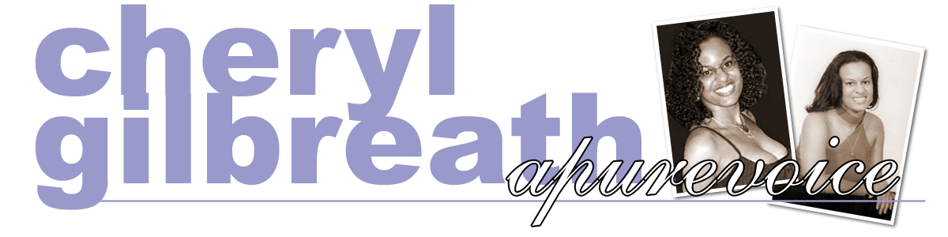

www.apurevoice.com

Born and raised in Oxnard, Southern California, Cheryl Gilbreath has been singing since she was a child. Her versatile soprano vocals can accommodate just about any musical genre from Sacred and Classical to R&B and Jazz. Her favorites include the inspirational ballads made popular by Whitney Houston, Mariah Carey, and Yolanda Adams. She also favors the operatic sounds of Kathleen Battle and the jazz trends of Natalie Cole.
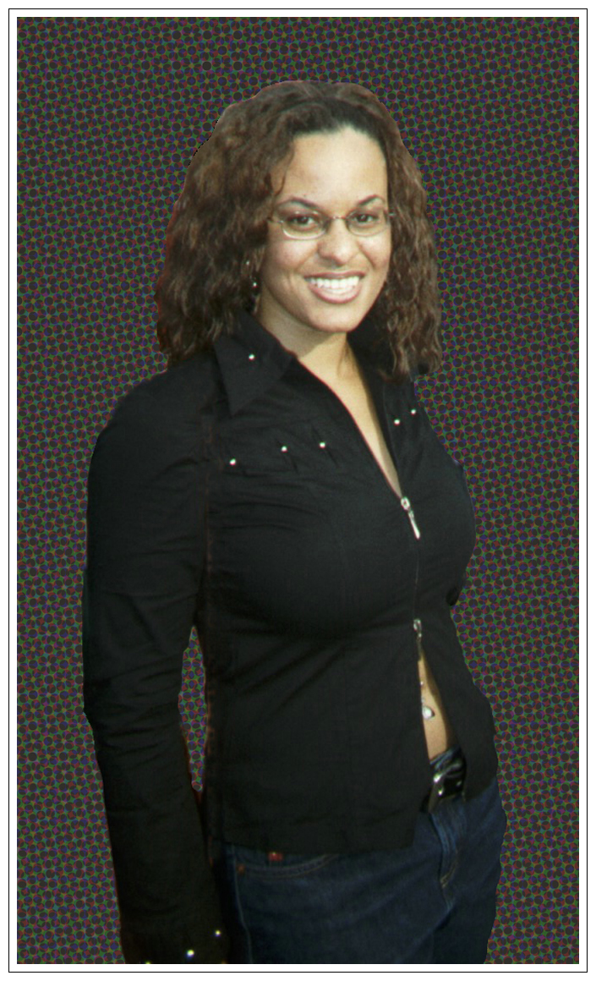
Eager to share her passion for praising God and celebrating His gift of voice, Cheryl welcomes any invitation and every challenge to grow spiritually and musically. She continues to sing for various church, campus and community affairs and upon graduating from Howard University in 2005, she plans to pursue her vocal performance career.

While at Howard University, Cheryl’s voice has developed over the years while singing 1st soprano soloist in the original Howard Gospel Choir, and currently the Rankin Memorial Chapel Choir with esteemed music director Arphelius Paul Gatling, III. The Rankin Chapel Services are broadcast on WHUR-96.3FM radio of Washington DC each Sunday at 11am.

Cheryl is noted as the “Pure Voice” of Oxnard, CA, attributing her many outstanding community performances. At age 12, she entered the jazz environment with the city’s popular Raw Silk Band and continues to sit in with them when she is in town. Her professional background is increasingly developing with various experiences including performing Harlem Blues for Spike Lee at Howard University, and singing Lift Every Voice and Sing at Howard’s Homecoming Step Show with an audience of over 6000. Cheryl has also performed for audiences including President William Clinton and Jessye Norman at the John F. Kennedy Center in Washington DC. Other performance locations include Chicago, New York, Los Angeles, and St. Thomas of the Virgin Islands.

She joined Marc Williams and Higher Calling, a contemporary Gospel ensemble, to participate in their live recording session hosted by Heaven-1580AM radio of Washington DC. Cheryl’s original studio recording, Just Friends was also aired on WPGC-95.5FM radio in Washington DC. She enjoys performing and recording with the popular smooth jazz saxophonist, Ray Silkman, in Chicago. She has collaborated with Ray another silky tune entitled, No Mas Murallas (No More Walls). While performing with her, Ray said, “Cheryl is just too good.”


Cheryl aims to continue performing for a wide variety of audiences. “I want to share my gift with anyone and everyone who can listen, and I believe that singing just one genre of music would be limiting. As long as the message is positive, I will definitely give my all.”

